Christopher Nieper Education Trust

We are delighted that Christopher Nieper Education Trust is embarking on the next exciting stage of its educational journey. The Trust was founded in 2015 and took on its first school in September 2016, the now David Nieper Academy, and are at the stage where the second school, Stonebroom Primary & Nursery School, is in the process of formally joining the Trust.

David Nieper Academy has developed over the last six years, starting with only 344 pupils 11-16 in the previous school buildings dating back from its opening in 1939. The fantastic new buildings opened in February 2017 and, despite it being a couple more years before the grounds were finally complete, the pupils and staff have been able to enjoy the benefits of working in a wonderful new building with new resources and equipment. The Sixth Form was reopened in September 2017, initially with a very small cohort of students who studied BTEC Business alongside a work experience programme in conjunction with our Sponsor, David Nieper Limited and other local employers. The Sixth Form was soon expanded to include Health & Social Care and now has a range of eleven BTECs and A-Levels covering all subject areas including new for this year A-Level Chemistry, History and Psychology.

The strong focus on employability across the academy has ensured that all pupils experience a wide range of employer contacts, from projects to presentations and visits, all underpinned by clear employability behaviours and attributes. The success of this approach is seen in the very strong progression routes of pupils at both age 16 and 18 with pupils progressing onto apprenticeships, employment with training or further study including vocational courses and university.

David Nieper Academy has gone from strength to strength and is now oversubscribed in most year groups being the sixth most oversubscribed secondary school in Derbyshire again this year. The academy will have grown to 820 pupils by September 2023. This growth has meant that every year the academy has been in the wonderful position of being able to recruit more staff both teaching and support staff all of whom have supported the continually improving results, ensuring that all pupils can progress successfully onto the next stage of their education and life.

The tremendous improvement of the academy supported by the Trust, was acknowledged by Ofsted in September 2022, when David Nieper Academy was graded as ‘good’ in all areas. A fantastic achievement for a school that only a few years ago had only 344 pupils and was in danger of closing.

Since the start of Christopher Nieper Education Trust the secondary school has worked very closely with the cluster of schools in Alfreton and the surrounding areas. This has included hosting activities such as the Year 2 & Year 5 Enterprise days, where children from the local schools work with academy staff and pupils on an Enterprise project. In addition, academy staff have led days each year for Gifted & Talented primary pupils in Science and Art to come and use the specialist facilities and complete a challenge. However, the event that has generated the most excitement is the annual Joint Concert. Each year David Nieper Academy hosts pupils from all the cluster schools for an evening of music and dance. Each school showcase their pupils’ work on the main stage with full lighting and sound and the show finishes with a joint choir from all the schools performing three pieces. The age range of the pupils spans from 5 to 16 and the event is now so popular that we have to run over two nights to allow all the schools who wish to take part to be able to do so.

Following on from our work with the local cluster of schools it became clear that a close relationship was developing with Stonebroom Primary & Nursery school. This has included working together on Family Support with staff now regularly working together and the first community event being held at Stonebroom Community Centre to highlight the range of services available in our local areas. The staff and Governors from both schools had the opportunity to meet and start to get to know each other at a joint event which led to other links in areas such as History, Geography and IT. The two schools also shared a bond in that the original key to Stonebroom school was found in a box in the safe at David Nieper Academy.

It has now been returned to Stonebroom and still opens the front door of the school!

There has been a school in Stonebroom since 1846, with the current building built in 1926. The school is one form entry, taking children from the age of 3 to 11. Many year groups are over- subscribed and there is a waiting list to get into the Reception class. The majority of pupils transfer to David Nieper Academy when they leave Stonebroom at the end of Year 6.

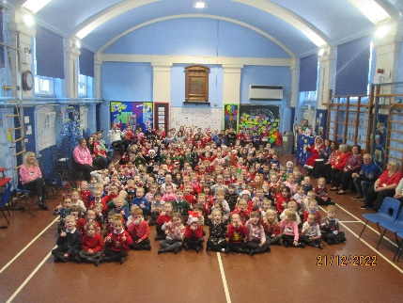Stonebroom Primary & Nursery School is a place where all children and staff are given the opportunity to excel. ‘Pupils are proud of, and enjoy coming to their school........Pupils respect their teachers and think that learning is important,’ Ofsted September 2019. Academic progress and attainment is always in line with, or above national expectations.

The most **recent Ofsted inspection** (September 2019) states that Stonebroom Primary & Nursery School is a **GOOD** school.

The curriculum offers skills and enrichment so that EVERY child is able to gain the foundations for a quality future life and a love for life-long learning.

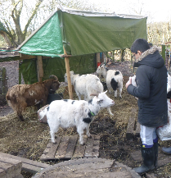The school mission statement is ‘Together Aspire, Together Achieve', and this is at the heart of everything that is done at Stonebroom. Whilst focusing on the core skills of reading, writing and maths, Stonebroom is a safe and happy place to be and provides a wide range of opportunities for all children to achieve their potential. The school believes that learning is not restricted to the classroom and that every child who attends Stonebroom has an entitlement to a range of visits and experiences that enrich and enliven the curriculum. Outdoor learning, creative arts, being eco-friendly and being a highly successful Forest School all form part of the teaching and learning programme.

After working closely with David Nieper Academy in a variety of guises, Stonebroom Primary & Nursery School are really excited about joining Christopher Nieper Education Trust.

Following lots of research and careful consideration and discussions with staff, parents and the wider community the Governors at Stonebroom Primary & Nursery School took the decision to request to join Christopher Nieper Education Trust. The formal process is well underway, and the school will become part of the Trust very early in the next academic year. While many things will remain the same at both Stonebroom School and David Nieper Academy, what will continue to develop is the close working relationship between the two schools to the benefit of all the pupils and staff. Both schools are also very much looking forward to other schools joining Christopher Nieper Education Trust in the near future. The Nieper Trust family is continuing to grow!

Mrs Sara George, Headteacher, Stonebroom Primary & Nursery School

Dr Kathryn Hobbs, CEO Christopher Nieper Education Trust / Headteacher, David Nieper Academy